**Central Tendency & 3 M s:**

**Arithmetic Mean:**

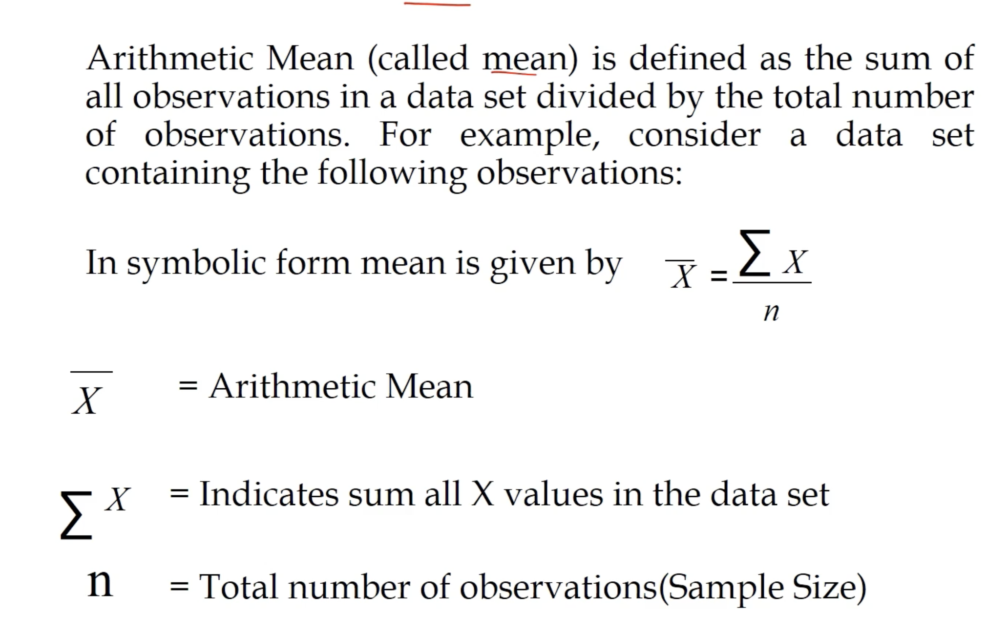

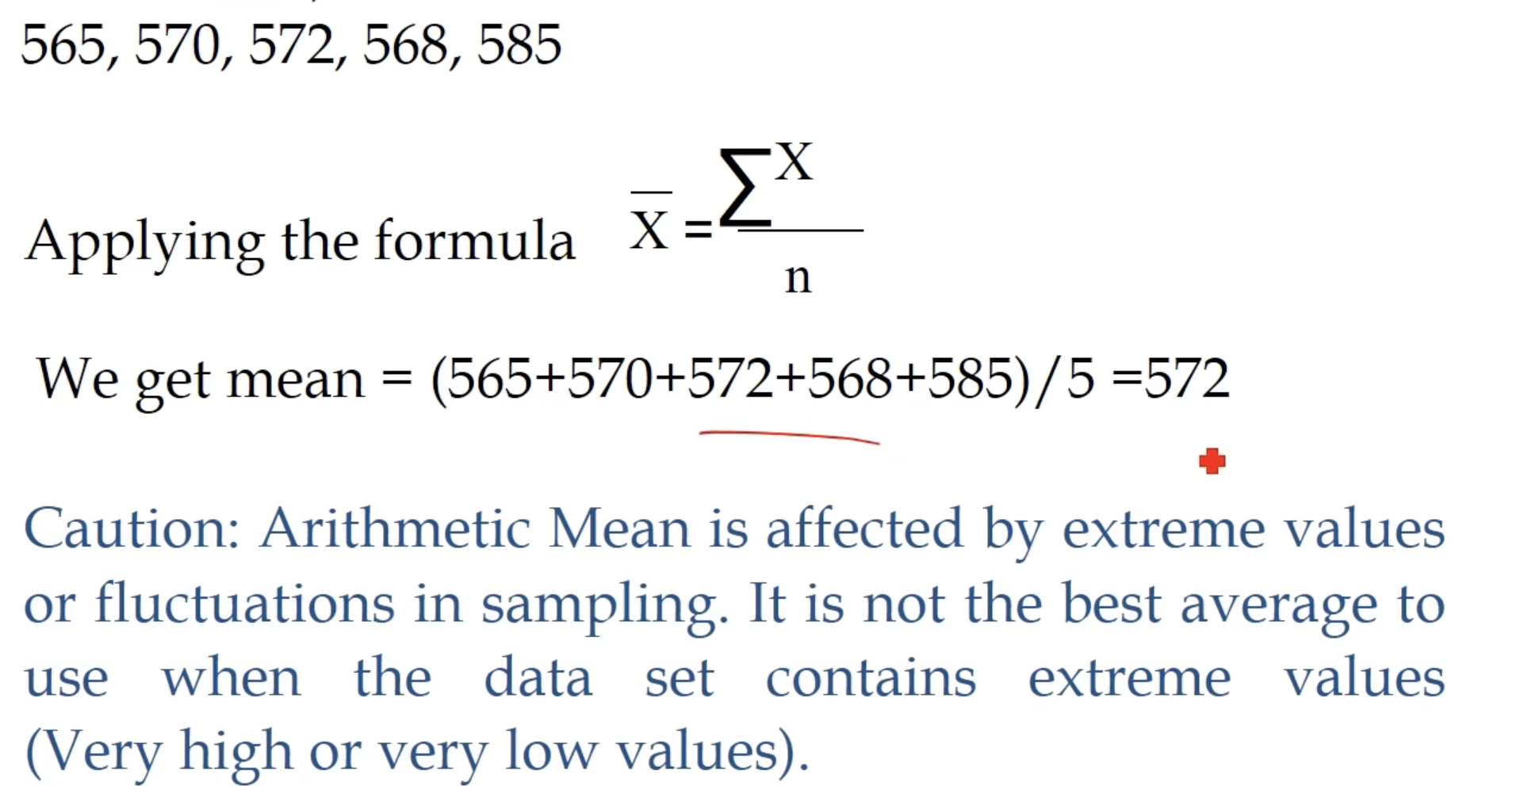

**Median**

* (For ODD dataset) A middle number after arranging data in ascending order
* (For even dataset) Find avg of two middle number after arranging data in ascending order

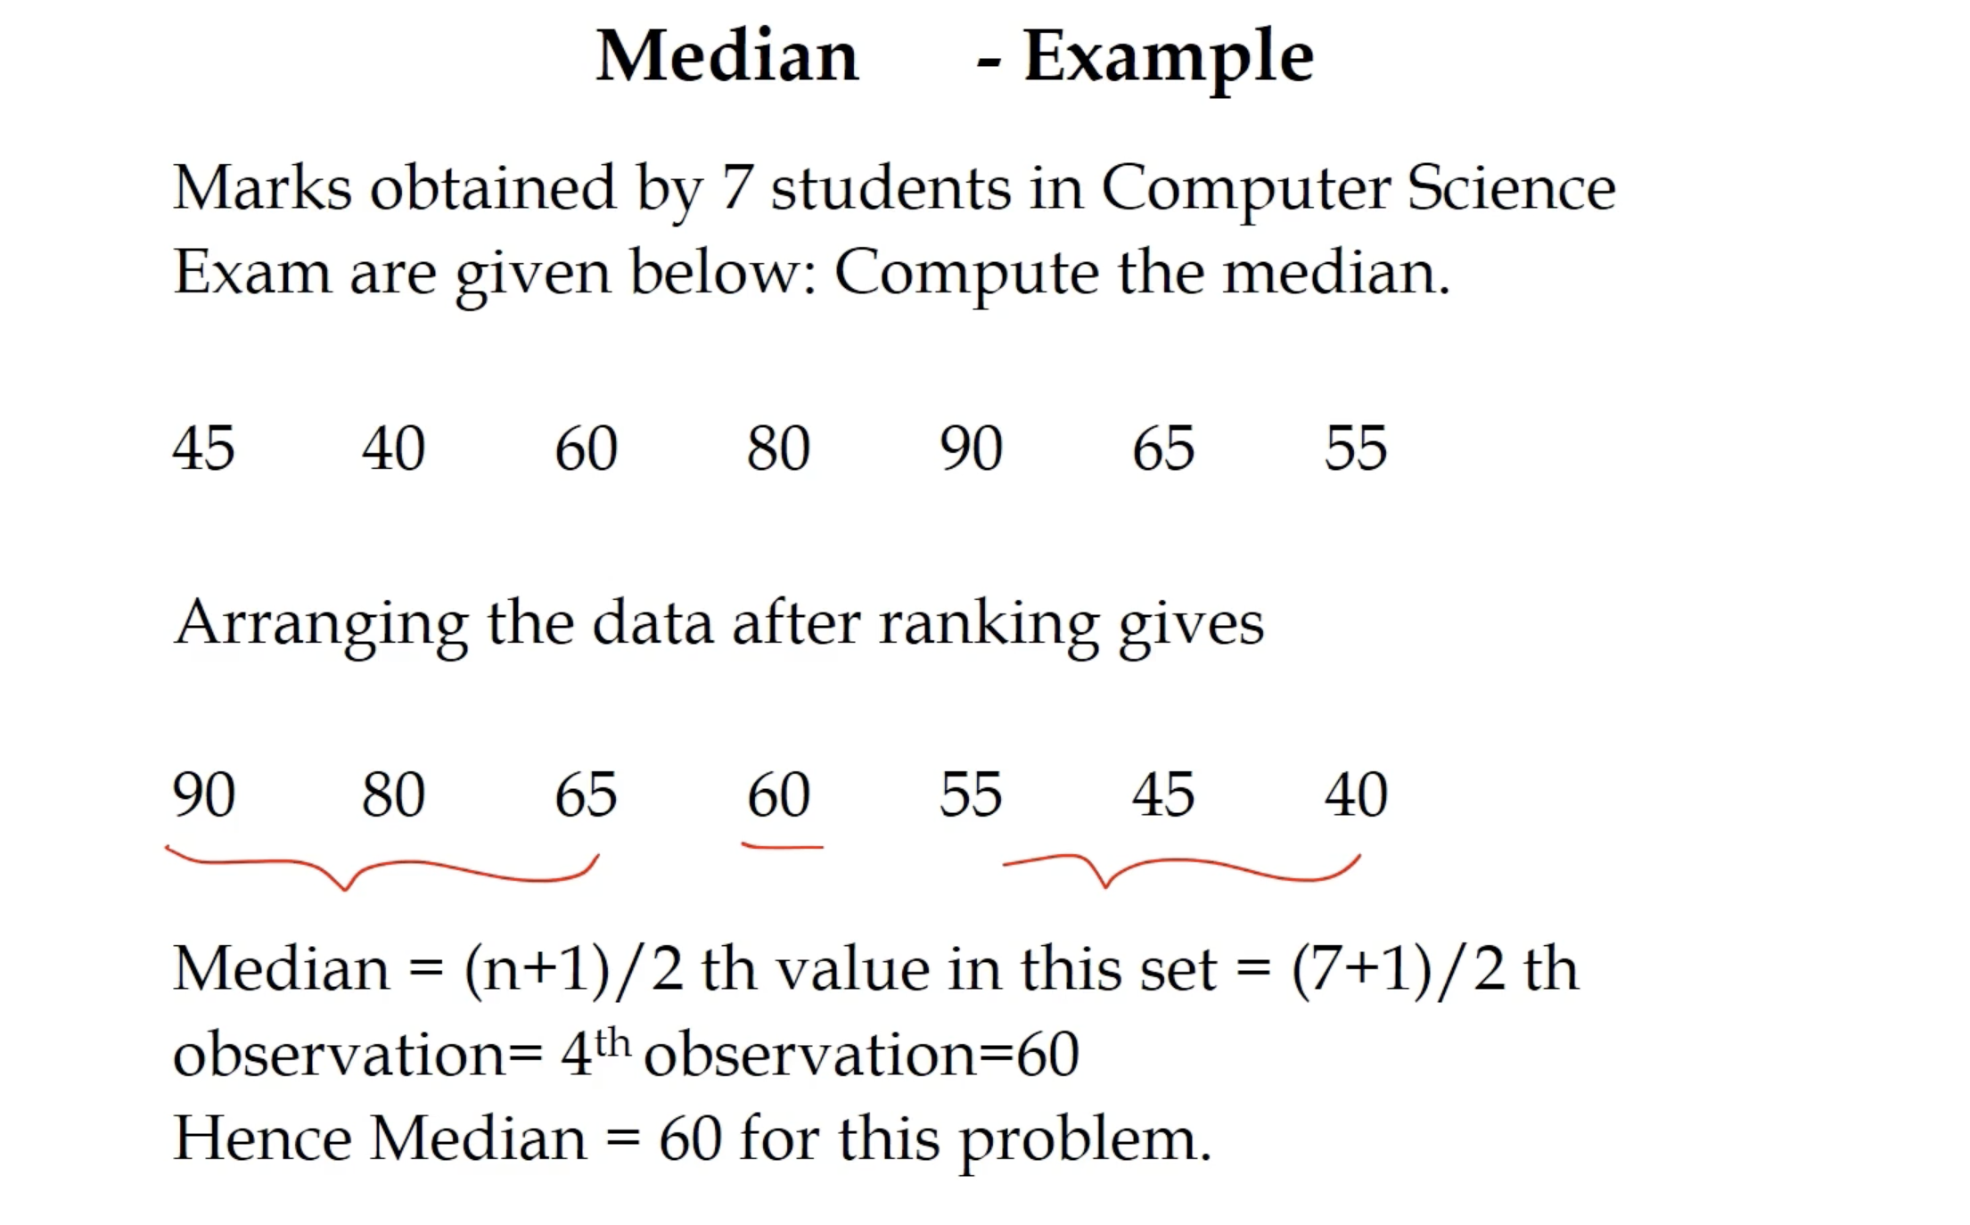

**Mode**

* Most frequent number

